NEWS ALERT
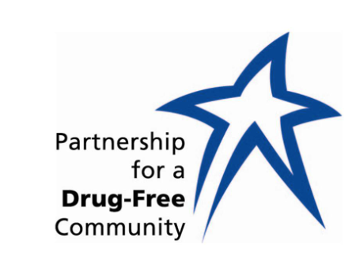

FOR IMMEDIATE RELEASE FOR MORE INFORMATION:
September 5, 2013 Deborah Soule, 256-539-7339

WANTED: HIGH SCHOOL AND COLLEGE STUDENTS

The Partnership for a Drug-Free Community is looking for students who have a positive attitude, average or better grades, a good school attendance record, school pride, and a desire to make a difference in the community. Students may apply or be nominated until Sept. 18 to participate in a new Partnership program called, Today’s Youth, Tomorrow’s Leaders.

The program will influence young people and adults to better understand the impact and dangers of prescription pills. Deborah Soule, Partnership’s executive director says prescription pill abuse is the fastest growing drug epidemic in the nation and that is destroying young and old alike.

Today’s Youth, Tomorrow’s Leaders will involve up to 30 students in grades, 10, 11, and 12, plus college students. The students will be trained by community leaders, law enforcement, media, political, public health, and education to effectively address the dangers of prescription pill abuse at local assemblies, churches, and civic groups.

The selected participants will meet 9 a.m. to 1 p.m. on Saturdays: September 21, September 28 and October 5, 2013, at the Huntsville Public Safety Training Center, 3011 Sparkman Drive, between Blue Spring Road and Pulaski Pike. Lunch will be served at no cost to the students.

More information about the program and applications may be found at www.partnershipforadrug-freecommunity.org/tytl, or by calling the Partnership office at 256-539-7339. Deadline to apply is Wednesday, Sept. 18.

